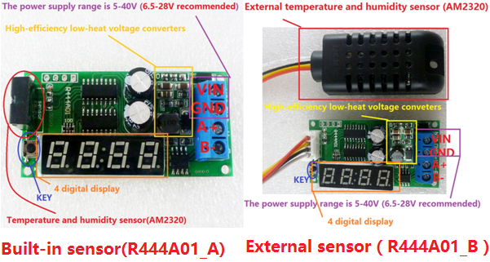

**Features:**

Working voltage ：DC 5-40V(6.5-28V recommended)

Working current：Digital tube turn off is 5MA(12V), Digital tube turn on is 18MA(12V)

MODBUS RTU protocol，03 Read，06 Write.

Serial baud rate：9600（default），N，8，1

By modifying the RS485 address, up to 247 module s can be connected (More than 16 devices, it is recommended to use RS485 repeater)

Temperature and humi dity sensor is AM2320

The voltage conversion module is DD4012SA,a High-efficiency and Low-heat voltage Converter

Size：Module is 59 X 30 X 18MM,Shell is 73 X 37 X 23MM, External sensor(only R444A01_B) is 60 X 26 X 13

Weight：Module is 16g，Shell is 16g, External sensor is 15g

Use Please refer to : "R444A01 modbus rtu protocol"

Note:

With the built-in sensor version (R444A01_A), turn on the display for a long time will Will let the temperature rise 1-2 degrees Celsius. It is recommended to turn off the digital tube, or use a version with an external sensor (R444A01_B)

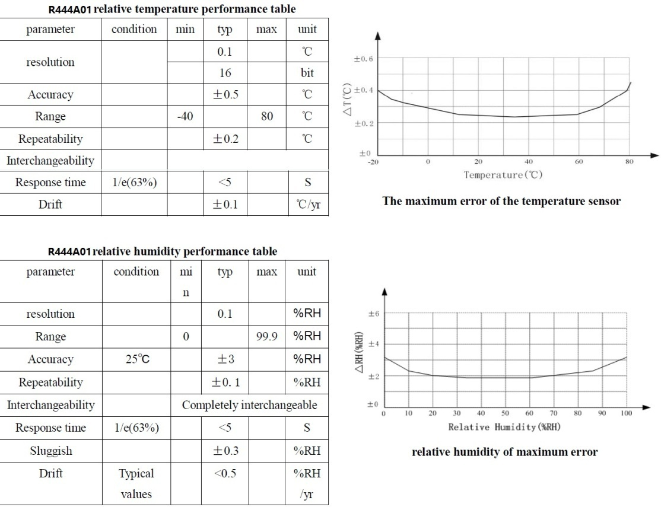

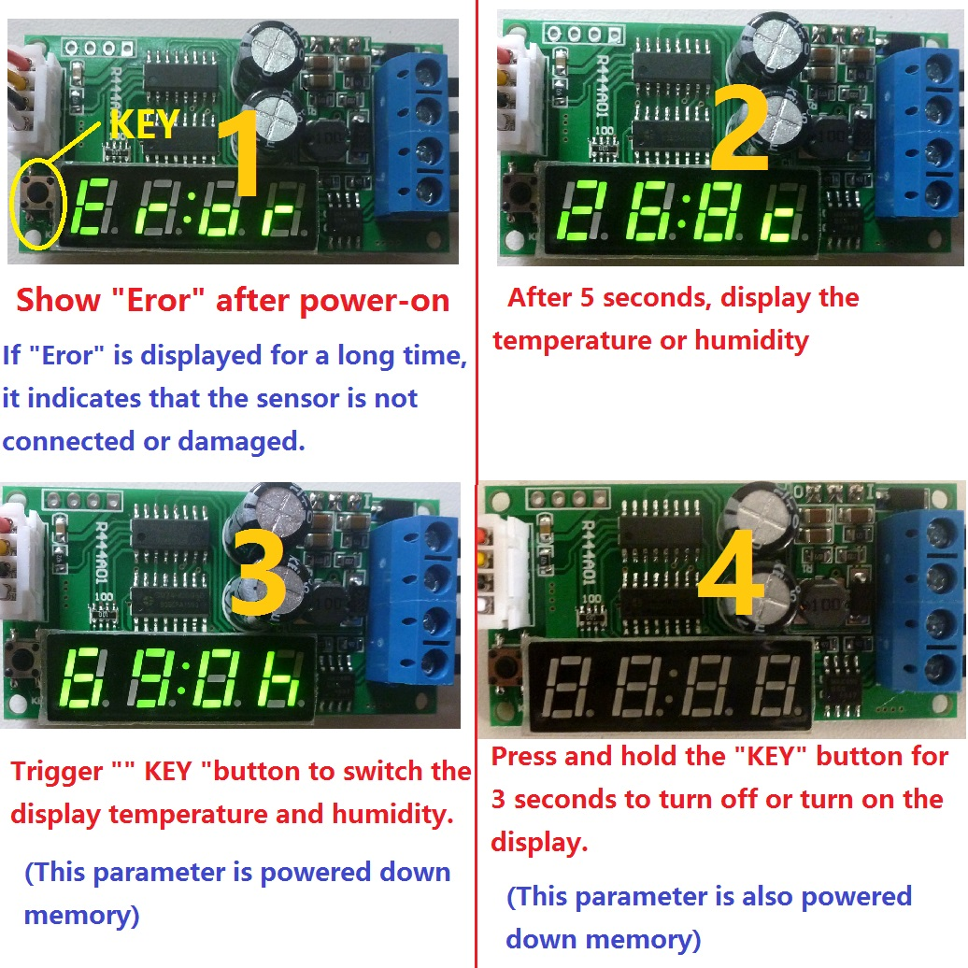

How to use:

1 Display "Eror" after power-on

If "Eror" is displayed for a long time, it indicates that the sensor is not connected or is damaged

2 After 5 seconds, display the temperature or humidity

3 Trigger " KEY "button to switch the display temperature and humidity.(This parameter is powered down memory)

4 Press and hold the "KEY" button for 3 seconds to turn off or turn on the display.(This parameter is also powered down memory)

Note: If the digital tube is turn off after power-on, press and hold the "KEY" button until the digital tube is turn on

Wiring diagram:

